Dear sportsfriends,

The Flemish lifesaving federation invites you to:
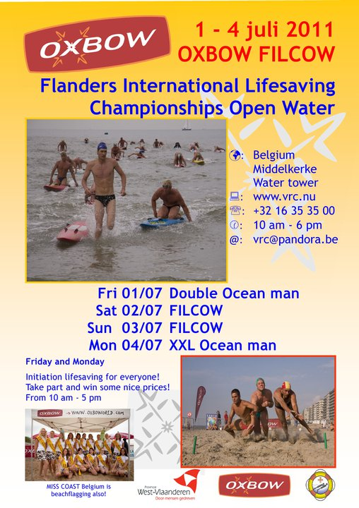
INTRODUCTION
We would like to invite you to the sixth Flanders International Lifesaving Competition Open Water. The Flemish lifesaving federation organises this competition together with lifesaving team COAST.
This year the OXBOW competition will be combined with the FILCOW.
You can participate in the three events.
Event 1: Double oceanman
Event 2: FILCOW: regular competitions with Beach flags – Beach sprint – Beach run – Surf race – Board race – Oceanman – Surf ski race
Event 3: Long distance oceanman

The results will be made up per gender, per discipline and in three different age groups:
2001-1997
1996-1972
1971-older

De technical rules of ILS will be applied during the competitions.

PROGRAMME
- Friday 1st of July: Double Oceanman
10h00 – 12h00: Board and Beach flags initiation
13h00 – 15h00: Double Oceanman

- Weekend 2nd and 3rd of July: Regular competitions - FILCOW

Saturday 2nd of July:
AM PM
Heats Board Finals Board
Heats Surf Ski Finals Surf Ski
Heats Beach Sprint Heats Rescue Board Rescue
Heats 4x90 Heats Oceanman
Finals 4x90 Finals Rescue Board Rescue
Finals Beach Sprint

Sunday 3rd of July
AM PM
Heats Beach Flags Finals Oceanman
Finals Beach Flags Heats rescue Tube rescue
Heats Surf race Finals rescue Tube rescue
Finals Surf race
Final Oceanman relay
Final 2 km

- Monday 4th of July: Long Distance Oceanman

10h00-14h00:
14h30-17h30: Long distance Oceanman

CLASSIFICATIONS

For the Double oceanman
- There are only prizes for the two age groups and per gender.

For the Long distance oceanman
- There are only prizes for the two age groups and per gender.

For FILCOW
- There is a ranking per event in each gender and in the three agegroups.
- There is an overall ranking where the best 4 results will be added up.

Pointscoring
- Each event will be held with series and finales.
- The points are as follows: (only in the final)
1° place = 20 pts. 2° place = 18 pts. 3° place = 16 pts.
4° place = 14 pts. 5° place = 13 pts. 6° place = 12 pts.
7° place = 11 pts. 8° place = 10 pts. 9° place = 8 pts.
10° place = 7 pts. 11° place = 6 pts. 12° place = 5 pts.
13° place = 4 pts. 14° place = 3 pts. 15° place = 2 pts.
16° place = 1 pt. 17° A.F. = 0 pts.

- Per athlete the best 4 scores will be taken into account.
- The athlete with the highest end score is the winner.
In case of a tie the place will be decided by the following ranking:
      - Oceanman
      - Board race
      - Beach flags
      - Surf race
      - Beach sprint
      - Surf ski
      - Beach run
For teams:
- Rescue board rescue race
- Rescue tube rescue race
- Beach relay
- Oceanman relay

SECURITY PROCEDURES

The Rescue Team of the Flemish Lifesaving Federation will take care of the competition’s safeguarding: there will be lifeguards in position on the beach and 1 or 2 boats at sea. The equipment must be in good state so that injury and danger is eliminated for the participants.

REGISTRATION

Terms of inscription
- Athletes can participate in all three events but can also subscribe for 1 or 2 events.
  - Double oceanman - Friday = only 1 event
  - FILCOW: weekend = athletes can participate in all 7 events
  - Long distance oceanman – Monday = only 1 event
- All athletes have to be member of an ILS recognised Lifesaving club.

- Each team can register for 4 relays (except 2001-1997 = no oceanmanrelay). A team consists of maximum 5 athletes of the same gender. An athlete can only be member of one team.

- The registration forms must be send before 20th of June 2011 to: sport@vrc.nu of whubregsen@vrc.nu

Vlaamse Reddingscentrale (VRC)
Gemeenteplein 26 – 3010 Kessel-lo
Telefoon: 016 35 35 00
Fax : 016 35 01 02

Competition registration on location
The registration of the participants can be done every day from Friday the 1ste of July at 8 o’clock until Monday the 4th of July at 11 o’clock but should be done one hour before the start of your first competition. The registration is at the beach side in the Red and Yellow Tent.

At each location you should marshal half an hour before the start. The chief referee will do the marshalling.

For further information you can contact Wijnand Hubregsen
- by e-mail: whubregsen@vrc.nu,
- by telephone: 0032 16 35 35 00
- mobile phone: 0032 476 66 82 09.

COSTS AND LODGING

Entry fee
The registration fee is 3,75 € per athlete per day and can be paid on the day of competition.

Costs for board and lodging
Everybody has to organise his own board and lodging. We will however be glad to help you with your accommodation if you encounter any problems.

LUNCH
Everybody has to take care of his own meals. For the weekend competition you can order prepared sandwiches by mailing your wishes to dcallens@euphonynet.be before the 20th of June.

We hope to encounter you on the 1st of July in Westende.

Beach There!

Kind regards

Wijnand Hubregsen
Sportsdirector VRC
Event Director

