Hotel arrangement for Open NC Pool Events

Hotel Eindhoven (10 mins walking to swimming stadium)
On motorway N2 (around Eindhoven) exit ‘Valkenswaard – Waalre’)

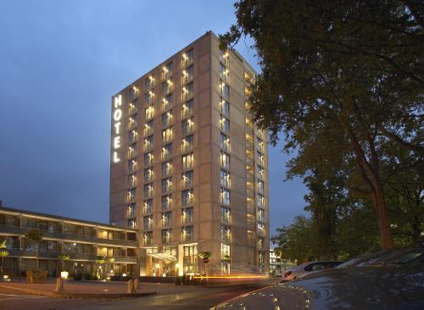

You can book the following special arrangement via us:
Standard room incl. breakfast for 1 person € 87,50
Standard room incl. breakfast for 2 persons € 102,00
Standard room incl. breakfast for 3 persons € 116,50
(Tourist Tax € 3,50 per person)

Book your rooms with Irma Timmermans-Takens. Send and email to:
irma_takens@hotmail.com (irma_takens@hotmail.com)

It is also possible to book a packed lunch for the competition day (€ 5,-).
Provide your own dinner (either at the hotel or a restaurant in Eindhoven).

We can also book training sessions in the pool for you. Contact Bob Dekkers:
e.dekkers7@upcmail.nl



